## Requirement Specifications

Requirement Specification is an important step in the software development life cycle. Although various software and hardware specifications can be used to develop this application, the software and hardware specifications that I have used to develop this job search portal are mentioned below:

### Software requirements:

* Operating System: Windows 10
* IDE/Text Editor: Sublime Text, Atom, Git Bash CLI
* Application Server: Node 3.10.10
* Frameworks/APIs: AngularJS, Sequelize ORM, Swagger, MySQL Workbench
* Database: MySQL
* Front End: HTML5, CSS3, Java
* Web Service: RESTful web services
* Browser: Preferable Google Chrome or Mozilla Firefox

### Hardware Requirements

* Processor: Intel core i5
* Processor Speed: 2.50 GHz
* RAM: 8 GB

# How to use the Online portal?

If you do not have an account “Click on register here to create a new account”

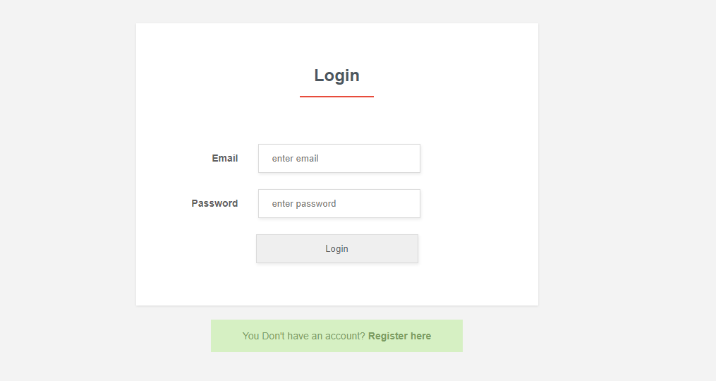

Once click you will be taken to this page to register

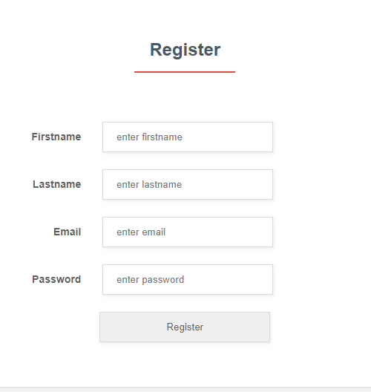

If you see this message then you have login and register correctly.



Once done. You will click on the green link where it said “qualification to add qualification”

And you will see a form like the one below.

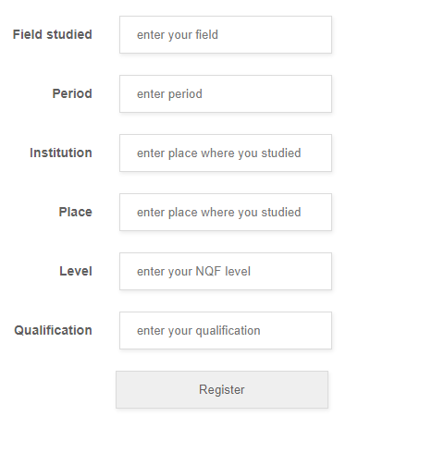

Once the qualification complete you can then add your work experiences

In a similar form like the one below

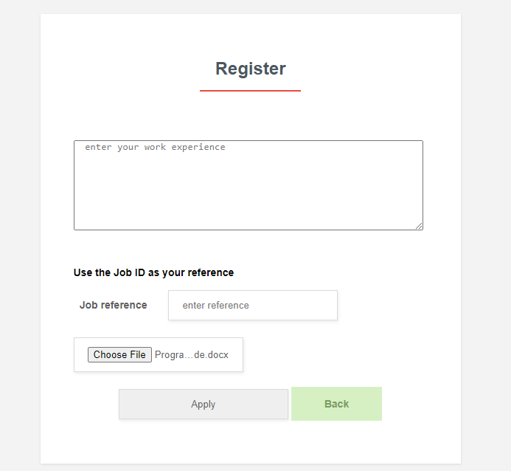

After every form completed you can then apply a job of your choice in a form like this one.

